#### Directed Energy Weapon Specs

#### Versatile and Highly Effective Weapon used to Explode an Incoming Missile - Latest Industry Trends & Key Insights by 2020

Download Free PDF Brochure at:   
[https://goo.gl/bRg2bu](https://www.linkedin.com/redir/redirect?url=https%3A%2F%2Fgoo%2Egl%2FbRg2bu&urlhash=AzMW&_t=tracking_anet)

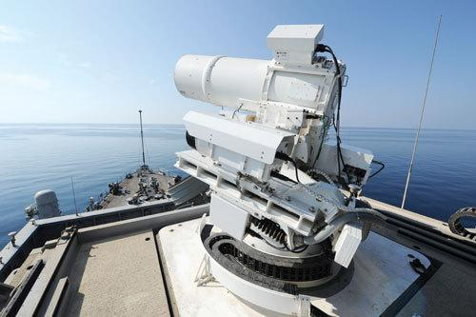

Most directed energy weapons (DEW) present the very unique advantage over conventional weapons of ammunition cost reduction. The cost per shot of directed energy weapons is far lesser than the same for conventional weapons. A DEW missile defense weapon, for instance, shoots high powered laser beams at an incoming missile to overheat it and cause it to explode  
  
Directed energy weapons are also versatile in utility as they can be used in warfare as well as in crowd control situations. DEWs are highly effective in dispersing crowds and riots and have been seeing an increase in use across the world. An example of a commonly used non-lethal crowd control DEW includes the Active Denial System.   
  
As a result of the above factors and others, the global market for directed energy weapons is expected to progress at a CAGR of 20.8% within a forecast period from 2014 to 2020, in terms of revenue. The market is expected to reach US$5.21 bn by the end of 2020.

Design specifics in mechanics and power are not available at this time.